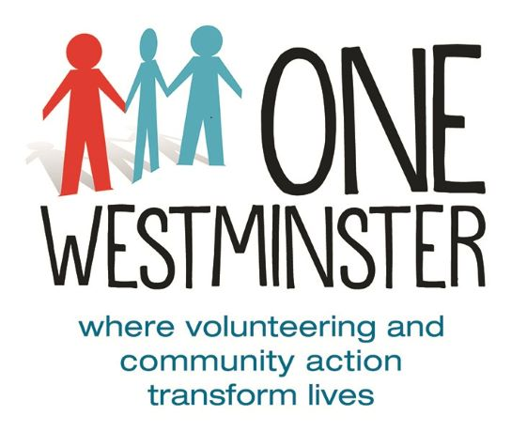
Flood Grant Application 2021

PLEASE RETURN YOUR FORM TO: j.rosenberg@onewestminster.org.uk

This is a grant fund to support Westminster residents whose property was damaged by the floods on Monday 12th July 2021 and who have no other means of recovering the damage (for example are uncovered by insurance). We will pay up to £200 per household.

Name:

Full Address with postcode, including whether you home is in a basement, ground floor or upper floor

Bank Account details: Name, Sort Code, Account Number:

Please describe the impact of the floods to yourself and your household:

Is the damage covered by your insurance? YES/NO

Please tick which applies: I don’t have insurance

My insurance does not cover the damage to these items

Please describe what you will use the grant for.

Please also provide proof of address and bank account details. This can be in the form of a photograph of a recent bank statement (showing name, address and bank account details) or 2 photographs, (e.g. a bank card showing name and bank account details; and a utility bill showing name and address). Screenshots from online banking or online utility bills are also acceptable. Bills and statements need to be recent (within the last 6 months).
Signed: Date:

If you have any difficulty completing this application form, please do get in touch with us by emailing j.rosenberg@onewestminster.org.uk or a.fagbemi@onewestminster.org.uk and we will do all we can to help.

PLEASE RETURN YOUR FORM TO: j.rosenberg@onewestminster.org.uk

