Gardening Volunteers Needed!

Join us to help make improvements in St John’s Wood Church Ground Gardens. This will include carrying out work in the only local nature reserve in Westminster.
You will be helping your local community - sandwich lunch provided and travel expenses refunded.
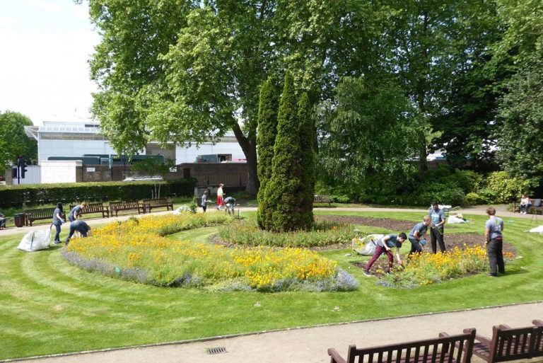

Wednesday 27 July 11am - 2pm
St John’s Wood Church Ground Gardens
NW8 7PF
Nearest Tube: St John’s Wood Station
Buses: 139,189,187,113,46

If you are interested call: 07918 759764 or
Email: n.barber@onewestminster.org.uk

