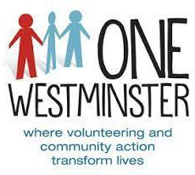**One Westminster**

**Your application and our recruitment process**

Thank you for responding to our recent advertisement. Enclosed is the following information:

 One Westminster’s mission statement and core functions

 Details of the job and person specification

 An application form

 A monitoring form

**How to apply**

The information you provide in your application is the **only** information we will use in deciding whether or not you will be shortlisted for an interview. Your application form is therefore very important, and the following advice is designed to help you complete it as effectively as possible.

**We will not accept a CV as part of your application.**

* The enclosed job description lists the main duties of the post, and the person specification describes the skills, experience and qualifications we are looking for.
* Please look at this carefully so that you know what the job involves, and the range of expertise required
* Consider all the relevant experience you have gained and tell us about it
* Application forms should be filled in as completely and clearly as possible so we can assess all candidates on the same basis. Do not substitute your CV for a completed application form since this will not be considered
* It is important that in completing the application form you respond to all the criteria in the person specification
* Volunteering and other unpaid work can be as valuable in providing skills as paid work
* Complete the form clearly
* If you are completing this form electronically ensure that you only use additional space where it is indicated that you may do so
* Ensure you send in your application by the closing date
* Our shortlist will be based on the skills and experience you show in the application

The questions we will ask at interview will be based on the job description and person specification and should give you the opportunity to expand on your application and to show us how you meet the essential requirements of the post. You will have the opportunity to ask questions about the job, conditions of service and so on.

**We look forward to receiving your application.**

**Closing date for receipt of application is 5.00pm on Tuesday, October 14th 2025**

**Interviews will be held on Thursday, October 23rd 2025**



**What is One Westminster?**

**From our Business Plan**

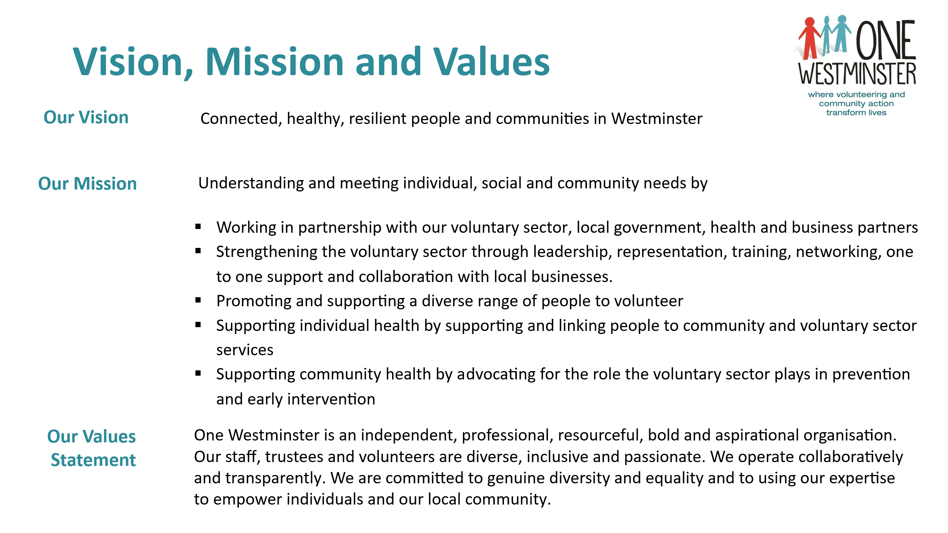

**More information on One Westminster can be found on our website: www.onewestminster.org.**

**Job Description:**

**Job Title: Events and Activities Volunteer Co-ordinator**

**Hours: 21 hours a week with some evening and week-end work**

**Reports to: Volunteer Services Manager**

**Salary: £35,000 pro rata**

**Annual Leave: 25 days pro rata**

**--------------------------------------------------------------------------------------------------------------------------**

This job description does not constitute a 'term and condition of employment'.  It is provided only as a guide to assist the employee in the performance of their job.  One Westminster is an evolving organisation and therefore changes to the employee’s duties may be necessary from time to time.  The Job Description is not intended to be inflexible or a finite list of tasks and maybe varied from time to time after consultation/discussion with the post holder.

**Main Purpose of Post:**

To take responsibility for: -

* The successful delivery of the annual Westminster Events Volunteering programme.
* The recruitment, training, managing and supervising of event volunteers at a series of events held across the borough of Westminster during the year.
* Working with key partners such as One Westminster(OW) Learning Disability Volunteering Project, Westminster Connects, One Westminster project staff and partner organisations’ event coordinators or project managers for external events.

**Key Responsibilities:**

* Recruitment, training, support and liaison of event volunteers with a priority given to people who live, work or study in Westminster
* Liaison with event contacts to understand responsibilities and task volunteers required for each individual event
* Liaison with Westminster City Council, including additional annual events that could be added to the programme
* Set up and manage database held of all event volunteers with key information and data as required
* Devising and coordinating a comprehensive volunteer recruitment programme supported by One Westminster’s Volunteer Centre team.
* Working alongside One Westminster Learning Disability Volunteering Project to establish a structure for additional support and volunteer mentors, as required, for events
* Attendance at all events alongside volunteers to ensure a high-quality service and support to volunteers at each event
* Full monitoring of all volunteer activity, including providing reports as required against contract targets
* Evaluation and learning from each event from event organisations, volunteers, and other key partners
* Managing all volunteers and any support staff that may be required for events
* Provide support as required for the Volunteer Centre Staff Team at One Westminster on various aspects of their work.

**General Responsibilities:**

* To identify and participate in relevant training
* To participate in supervision meetings and OW staff meetings
* To demonstrate a commitment to the values, aims and objectives of One Westminster
* To be able to work as part of a team
* To always carry out responsibilities with due regard to all One Westminster’s policies and procedures.

**--------------------------------------------------------------------------------------------------------------------------**

**Person Specification: Events and Activities Volunteer Coordinator**

**Experience:**

1. Experience of working in the voluntary sector - **desirable**
2. You will have a proven track record in project management - **required**
3. You will ideally have experience of working with adults with learning disabilities -**desirable**
4. Experience of managing volunteers - **required**
5. Experience of organising projects and events - **required**
6. Experience of delivering training sessions and facilitating groups - **required**

**Skills and abilities:**

1. You will have the skills to self-start and self-manage as well as working within a team and a wider organisation. - **required**
2. You will have the ability to work and be able to respond to pressures relating to prioritisation and time management. - **required**
3. You will be able to effectively manage databases for the project - **desirable**
4. You will have excellent report writing skills and communication skills with a wide range of people - **required**
5. Excellent presentational skills and ability to network with stakeholders - **required**
6. You will have skills in working with Microsoft packages and other IT software - **required**

**Attributes:**

1. A non-judgmental way of working - **required**
2. Commitment to equal opportunities principles and an understanding of inequalities and discrimination. - **required**
3. Willing to work evenings and weekends as needed – **required.**

**ENDS**



One Westminster

### JOB APPLICATION FORM

### Confidential

Please complete this form in black ink or type and send it to: [**info@onewestminster.org.uk**](mailto:info@onewestminster.org.uk)

CVs will not be considered

|  |  |
| --- | --- |
| Application for post of | **Events and Activities Volunteers Coordinator** |

|  |  |  |  |
| --- | --- | --- | --- |
| **PERSONAL DETAILS** | | | |
|  | | | |
| Surname |  | Initials |  |
|  |  | | |
| Address |  | | |
|  |  | | |
| Telephone: HOME |  | WORK |  |
| MOBILE PHONE |  |
|  |  | | |
| Email Address |  | | |

|  |  |
| --- | --- |
| Where did you hear about this vacancy? (Please state) |  |

|  |  |
| --- | --- |
| Do you have the right to work in the UK? (Please indicate) |  |

|  |  |  |  |
| --- | --- | --- | --- |
| REFEREES | | | |
| Please give us the names, addresses and telephone numbers of two people who can comment on your ability to do this job. One of these people should be your most recent employer, but if you have not been employed recently, a course tutor or someone you know from working as a volunteer can be used. Please state your relationship with each of these referees. References may be requested before interview. Please also say whether we can contact your referees before an offer is made | | | |
| First Referee: | | | |
|  | | | |
| Name |  | Telephone No |  |
|  | | | |
| Address |  | Relationship with referee |  |
|  |  |  |
|  | May we contact this person now? |  |
| |  |  | | --- | --- | | Email Address |  | | | | |
| Second Referee: | | | |
|  | | | |
| Name |  | Telephone No |  |
|  | | | |
| Address |  | Relationship with referee |  |
|  |  |  |
|  | May we contact this person now? |  |

|  |  |
| --- | --- |
| Email Address |  |

|  |  |  |  |
| --- | --- | --- | --- |
| EDUCATION AND TRAINING | | | |
| Please give details of schools/colleges/courses attended, and any qualifications obtained.  Please also give details of any relevant training including professional and inhouse work-based training courses that you have passed (most recent at the top) | | | |
| **From** | **To** | **Course Title & Institution** | **Result** |
|  |  |  |  |
|  |  |  |  |
|  |  |  |  |
|  |  |  |  |
|  |  |  |  |
|  |  |  |  |
|  |  |  |  |

|  |  |  |  |
| --- | --- | --- | --- |
| EMPLOYMENT | | | |
| Please give details of your employment, start with your current or most recent work. | | | |
| **From** | **To** | **Post & Employer** | **Reason for leaving** |
|  |  |  |  |
|  |  |  |  |
|  |  |  |  |
|  |  |  |  |
|  |  |  |  |
|  |  |  |  |
|  |  |  |  |

|  |
| --- |
| VOLUNTARY WORK |
| What experience do you have of voluntary work in the community? Please describe any voluntary work experience relevant to your application. This may include work in voluntary organisations, youth clubs, religious or cultural organisations, schools, sport etc. (Continue on a separate sheet if necessary) |
|  |

|  |
| --- |
| THIS POST AND YOU |
| You have read the enclosed job description carefully. Please say briefly why you want *this* job particularly |
|  |

|  |  |
| --- | --- |
| **SPECIFIC INFORMATION** | |
| Please use this section to tell us how your experience, skills, knowledge and qualifications will enable you to do this job. Address each item on the person specification individually in the same order as set out in the person specification. Please put the number of each of the criteria you address in the margin. Answer each point in detail, for example it is not enough to simply say ‘I understand the principles of Equal Opportunities’: you need to explain why you think it is important, to demonstrate your understanding to the short-listing panel. Continue on a maximum of 2 further pages if needed. | |
| **Criteria** |  |
|  |  |
|  |  |

|  |  |
| --- | --- |
| Please state the additional languages you speak, if any |  |

|  |  |
| --- | --- |
| Please state if you have a disability and/or if there are any reasonable adjustments, we need to be aware of |  |

|  |  |  |  |  |
| --- | --- | --- | --- | --- |
| If appointed to the post, when could you begin work? | | |  | |
| I confirm that all the information given in support of this application is accurate. I understand that obtaining employment at OW based on inaccurate information may result in my subsequent dismissal. | | | | |
| Signed |  | Date | |  |

|  |
| --- |
|  |

Please send your completed application to [**info@onewestminster.org.uk**](mailto:info@onewestminster.org.uk)

Please note CVs will not be accepted.

**We look forward to receiving your application and monitoring form**

**Closing date for receipt of application is Tuesday, October 14th at 5.00pm**

**Interviews will be held on Thursday October 23rd 2025**

 **Monitoring form**

We wish to make sure that as an employer we are providing equality of opportunity to all people regardless of race, colour, religion, sex, ethnic origin or disability. To help us achieve this, please would you fill in the questionnaire below.

If you choose not to answer, this will not prejudice your application.

|  |  |  |  |  |  |  |  |  |
| --- | --- | --- | --- | --- | --- | --- | --- | --- |
| Gender (please tick) | | Male | Female | | Non-Binary | | Prefer not to say | |
| Age (please tick one) | | | | | | | | |
| 16-19 | 20 – 29 | 30 – 39 | | 40 – 49 | | 50 – 59 | | 60+ |

|  |  |  |
| --- | --- | --- |
| How would you describe your ethnic background? | | |
| White |
| White British | White Irish | White Other |

|  |
| --- |
| Mixed |
| White and Black Caribbean | White and Black African | White and Asian |
| Any other mixed background (please say which) |  | |

|  |
| --- |
| Asian or Asian British |
| Indian | Pakistani | Bangladeshi |
| Any other Asian background (please say which) |  | |

|  |
| --- |
| Black or Black British |
| Caribbean | African |  |
| Any other Black background (please say which) |  | |

|  |
| --- |
| Other ethnic group |
| Chinese | Arabic | Other (please state |
| Any other ethnic group (please say which) |  | |

|  |  |  |  |
| --- | --- | --- | --- |
| Faith/religion (please tick one) | | | |
| Buddhist | Christian | Hindu | Jewish |
| Muslim | Sikh | None | Other (specify) |

|  |  |  |  |
| --- | --- | --- | --- |
| Sexual orientation (please tick) | | |  |
| Bisexual | Heterosexual | Lesbian or gay | Other |

If you have a disability or special communication needs that you think we should know about, please use this space to tell us about them.

|  |
| --- |
|  |

Your application and the information you give on this form will be kept strictly confidential and will be separated from the recruitment process.

Thank you. One Westminster.