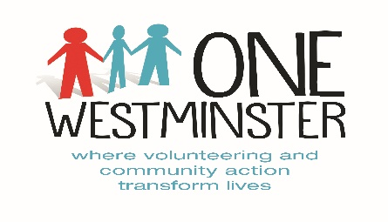

Befriending Plus

Criteria & Guidelines for Referral Agencies

Eligibility:

Essential Criteria
Westminster resident
Over 65 years old
Living alone or with limited social companionship

Service exclusions:

Exclusions
Mid/advanced dementia or Alzheimer’s or mental health issues
High care needs with no carer support e.g. needs lifting, cannot transfer from a wheelchair

One Westminster will work in partnership with West London Clinical Commissioning Group and the Kensington & Chelsea Social Council to monitor our outcomes.

Referring to the service

Please complete the form as fully as possible and send it to wellbeing.service@nhs.net. This is a secure email address that must be used for the referral process. For any queries, please contact 020 7535 0497.

Please ensure that the person you are referring is aware of the referral and inform them that someone from One Westminster will be in touch over the phone about befriending.

Befriending Plus Referral Form

CONTACT DETAILS
Title:
First Name: | Last Name:
DOB: | NHS Number:
Address:
Postcode:
Telephone Number (Mobile):

Reasons for requesting a volunteer befriender:

What social interaction would be required from a befriending relationship - companionship, outings, reading or other activity?

Level of family or social support currently available:

Relevant medical history details, including mental health and mobility:

EMERGENCY CONTACT DETAILS (Please note these will be given to the service user’s volunteer befriender for use in case of emergency)

Relationship:  Name:  Address:  Telephone No: | General Practitioner:  Name:  Address:  Telephone No:
REFERRER’S CONTACT DETAILS (if appropriate)

Name:

Organisation:

Address:

Postcode:
Telephone: | Mobile (if applicable):
Email:

Signature: Date of referral:

Please return this form marked CONFIDENTIAL to: Befriending Plus Project Coordinator, One Westminster, 37 Chapel Street, London, NW1 5DP. Telephone: 020 7535 0497or Email to: wellbeing.service@nhs.net

